# How To Protect Your RV Cover ― Use Your Noodle!

### RV Maintenance Tips and Tricks

This RV maintenance article describes how we used a very common ***toy*** to protect our new RV cover from tears and other damage from sharp corners and protrusions on our travel trailer. You can protect your RV cover the same way.

#### The Project —



*Pool Noodles*

We live in New Hampshire. We winterize our RV and store it for the winter outside our home. Our winter weather is cold, snowy, and sometimes windy. In past years, to protect our RV from this winter nastiness, we have covered the roof with a big, heavy duty tarp tied down using tent stakes, ropes, and bungee cords. This has worked pretty well, but the heavy duty tarps don’t “breath” too well and the tarp didn’t do much to protect the sides of the rig and the windows, doors, compartment hatches, and so forth. Since the tarp we’d been using had gotten somewhat threadbare and even developed a couple of small holes, we were planning to buy a new one.

Then we ran across a Camping World online sale offering really good prices on ADCO Designer Series Tyvek RV covers. These have a Tyvek top and polypropylene side panels, each with three layers of material. They’re supposed to be designed for use in wet and/or snowy areas and to be “breathable” to prevent the accumulation of condensation between the RV and the cover. Soooo…rather than spend over $100 to replace the tarp, we decided to bite the bullet and spring for the full RV cover. These covers come with a two year warranty, but we’re certainly hoping it will last longer than that.

And, that’s what this project is all about. Our travel trailer has quite a few places that have the potential to cause rips or to wear holes in the cover fabric. Windy, or even just breezy weather will cause movement of the cover over the various surfaces of the RV. Can’t be helped. We knew we should find ways to pad any sharp corners or edges or protrusions that could damage the cover. The question was, what to use to pad these areas? We had used chunks of foam rubber – from an old mattress – before on the spouts. They’d worked ok, until they blew off when the tarp billowed up in the wind. Styrofoam is too brittle and breakable. Cardboard could get damp and fall apart.

Then one of us had an epiphany. NOODLES! You know, those colorful foam thingies the kids play with in the pool or at the lake. They’re made of waterproof foam that is soft enough to protect the cover, but rigid and springy enough to grip something and stay in place – or, if necessary, we could tape them in place with some painter’s tape. They are easy to cut and shape with a simple utility knife. It being the end of the summer, Deb found some on sale at Walmart and brought home 7 or 8 “Monster Funnoodles.” The rest of this post attempts to describe and show how we used them to protect our new 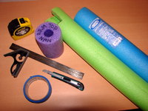RV cover.

*Tools*

#### 1-Tools —

* Tape measure
* Utility knife
* Sharpie marker
* A square (didn’t use it much at all)
* Some contact cement
* A roll of blue painter’s tape

#### 2-Gutter Spouts —

I started with these, perhaps because they stick out pretty noticeably. They’re not particularly sharp, so maybe it’s more about protecting them from the cover! Anyway, after taking a good look, I was scratching my head as to the best way to create a pad for them. The pictures tell the story:

*Fig. 1 Fig. 2 Fig. 3 Fig.4*

[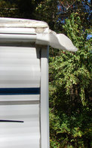](https://www.rvcampinginfo.com/wp-content/uploads/2014/11/GutterSpout.jpg)[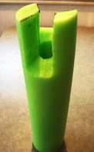](https://www.rvcampinginfo.com/wp-content/uploads/2014/11/GutterSpouts1.jpg)[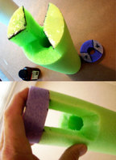](https://www.rvcampinginfo.com/wp-content/uploads/2014/11/GutterSpouts3-4.jpg)[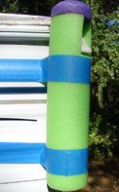](https://www.rvcampinginfo.com/wp-content/uploads/2014/11/GutterSpouts4.jpg)

 The spout extensions stick out from the corners of the rig at what might be called a compound angle (Fig. 1). In order to have these pieces fit snugly and support the extensions, they were probably the toughest ones to measure and cut. I pretty much just eyeballed the thing and experimented with how to cut the top of the noodle until I got the right shape and the right angles to fit over and support the spout extension (Fig. 2). After I got the first one to fit, it was pretty easy to cut another to match it. I had started on the right front corner. The matching piece fit the left rear corner, but then I realized that the pieces for the left front and the right rear corners needed to be mirror images of the first two. With just a bit of fussing, I got those cut also.

Ok, so maybe I got a little carried away with the design – purple top and all – but they are kinda cute. Next time, I would probably cut the things so each was only one piece and I didn’t have to glue a top piece on (Fig. 3). Finally, I used painter’s tape to fasten each gutter spout pad to the corner of the rig (Fig. 4). I’m sure some of you would do it differently, and maybe better, but I think these will work.

#### 3-Things On the Roof —

Most of the things that stick up from the roof — A/C, vent covers, refrigerator vent cover, bathroom skylight, etc. — are smooth and rounded and clearly won’t puncture or tear the cover. The TV antenna, however, has a couple of areas with somewhat sharp edges that stick up and could cause damage, particularly under the weight of a load of snow. Same with the mount for the radio antenna. Better to be safe, and all that.

*Fig. 5 Fig. 6 Fig. 7*

[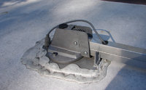](https://www.rvcampinginfo.com/wp-content/uploads/2014/11/TVAnt.jpg)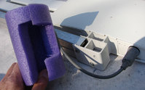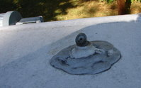

*Fig. 8 Fig. 9 Fig. 10*

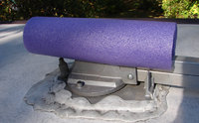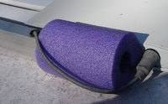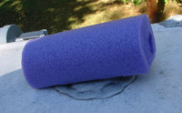

For the base bracket of the TV antenna (Figs. 5 & 6), I simply cut a roughly 1” wide piece out of the length of the noodle section, leaving around 3” of uncut section on each end. This cutout fit down over the bracket snugly. At the other end (Figs. 7 & 8), I had to be a bit more creative with the cutout. For the radio antenna base (Figs. 9 & 10), I just cut a hole in the noodle to fit tightly over the protruding piece.

#### 4-Bottom Corners —

[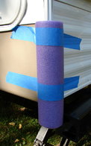](https://www.rvcampinginfo.com/wp-content/uploads/2014/11/BottomCorner-Pad.jpg)

*Fig. 12*

[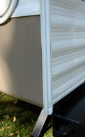](https://www.rvcampinginfo.com/wp-content/uploads/2014/11/BottomCorner.jpg)

*Fig. 11*

The instructions that come with the ADCO cover specifically mention padding the bottom corners (Fig. 11) of the rig. With elastic front and rear bottom edges and straps that pull the sides together under the RV, the cover material is bound to rub on the rig’s bottom corners. On our rig at least, those corners are sharp enough to almost certainly cut the cover material after a while. Here’s how we dealt with those:

These were easy. I just cut a notch from the entire length of the noodle. This fits nicely over the corner of the rig and is held on with painter’s tape (Fig. 12).

#### 5-Slide Bottoms —

Our trailer has two slides. The outer frame of the bedroom slide has no sharp corners or protrusions that can damage the cover. The dinette slide, however, includes the bottom skirting of the trailer. Where the bottom of the outer frame of the slide mates with the bottom of the frame of the opening, there are some very sharp edges and corners (Fig. 13). Since the RV cover wraps under the bottom edge of the skirting, this would almost certainly tear the material sooner or later.

[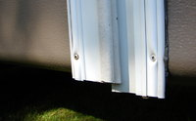](https://www.rvcampinginfo.com/wp-content/uploads/2014/11/SlideFrameBottom.jpg)

*Fig. `13*

[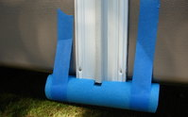](https://www.rvcampinginfo.com/wp-content/uploads/2014/11/SlideFrameBottom-Pad.jpg)

*Fig. 14*

[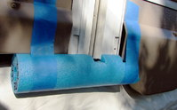](https://www.rvcampinginfo.com/wp-content/uploads/2014/11/SlideFrameBottom-Pad2.jpg)

*Fig. 15*

The right-hand side of the slide frame (Fig. 14) required just slitting the noodle piece from end to end, with a small cutout to fit around a protruding area. The other side comes in the middle of the fender skirt (Fig. 15) and needed more trimming and fitting to accommodate the curve of the fender. Both required a couple of pieces of tape to hold them in place.

#### 6-Patio Awning —

There were only five spots related to the awning that concerned me. The top ends of the support arms where they connect to the awning roller (Fig. 18), The brackets at the bottoms of the support arms where they fasten to the side of the rig (Fig. 16), and the bottom of the center awning support arm (Fig. 20).

[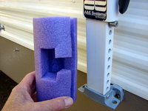](https://www.rvcampinginfo.com/wp-content/uploads/2014/11/AwningArmBracket.jpg)

*Fig. 16*

[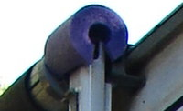](https://www.rvcampinginfo.com/wp-content/uploads/2014/11/AwningTop.jpg)

*Fig. 18*

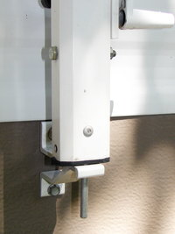

*Fig. 20*

[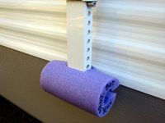](https://www.rvcampinginfo.com/wp-content/uploads/2014/11/AwnBracket-Pad.jpg)

*Fig. 17*

[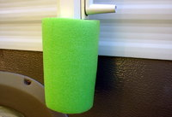](https://www.rvcampinginfo.com/wp-content/uploads/2014/11/AwnCentSup-Pad.jpg)

*Fig. 19*

The bottom of the center awning support arm sports a 3” long pin that, when the support is in use, fits into a hole in the awning roller. Would it ever puncture the cover material? Who knows, but it was so easy to just slit one side of the noodle piece and snap it over the thing (Fig. 19), why not? As for the tops and bottoms on the outer support arms, there was nothing really sharp, but to prevent unnecessary wear I made pads to be safe (Figs. 17 & 18).

#### 7-Steps & Misc.  —

I was most concerned about the sharp corners at the bottom of the side plates of the stair assemblies (Fig. 21). If the cover material gets hooked on those, damage seems almost certain. Part of the assembly also sticks out above those sharp corners. It’s not really sharp, but could certainly cause wear after a while. As you can see from the pictures, vertical pieces of noodles slit down one side, with a little cutout to fit over the round hand-grip bar, and resting on the bottom cross piece (Figs. 22 & 23) look as though they will do the trick. I made one for each side of the step assembly, for both doors (Fig. 24).

[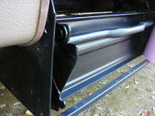](https://www.rvcampinginfo.com/wp-content/uploads/2014/11/EntryStep.jpg)

*Fig. 21*

[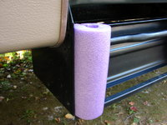](https://www.rvcampinginfo.com/wp-content/uploads/2014/11/EntryStep-Pad2.jpg)

*Fig. 23*

[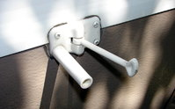](https://www.rvcampinginfo.com/wp-content/uploads/2014/11/DoorBumperHolder.jpg)

*Fig. 25*

[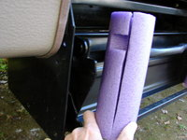](https://www.rvcampinginfo.com/wp-content/uploads/2014/11/EntryStep-Pad.jpg)

*Fig. 22*

[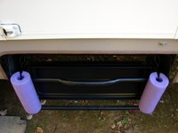](https://www.rvcampinginfo.com/wp-content/uploads/2014/11/Entry-Step-Pads3.jpg)

*Fig. 24*

[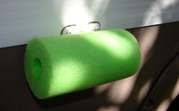](https://www.rvcampinginfo.com/wp-content/uploads/2014/11/DoorBumperHolder-Pad.jpg)

*Fig. 26*

The other things that stick out on the side of the trailer are the bumper and holder for each door (fig. 25). Again, they’re not really sharp, but I figured they’d cause wear after a while. All I did was cut a hole in the noodle snug enough to hold the pad on the door bumper (Fig. 26).

#### Final Thoughts  —

I didn’t really keep track of just how long all this took me to complete. I worked at it a little here and a little there. What took the longest was probably deciding what to pad, and the best way to fit a pad to each spot. The design work, so to speak. Cutting and fitting some of the pieces took a bit of “fussing,” and the actual mounting and fastening of the pads went quickly. If I had done it all at once, I’m pretty sure I’d have been done in a day. One nice thing is that these pool noodles are tough and I’d expect the pads to last for several years.

[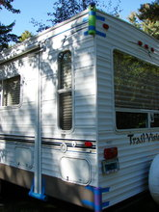](https://www.rvcampinginfo.com/wp-content/uploads/2014/11/RigWithPads-2.jpg)[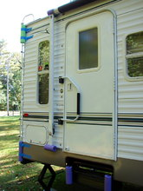](https://www.rvcampinginfo.com/wp-content/uploads/2014/11/RigWithPads-1.jpg)[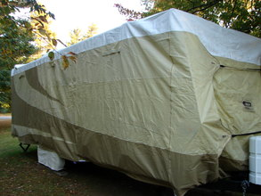](https://www.rvcampinginfo.com/wp-content/uploads/2014/11/AllWrappedUp.jpg)

 These last photos show some of the pads in place on the rig, and the thing all wrapped up in its new cover. If you click on any of the images in this post, they should open up in a larger size. I’ll admit, I caught myself wondering if this was overkill. Did I really need to pad all these areas? I guess time will tell. I hope these pads will be effective in preventing or reducing wear, tears, and punctures to the RV cover through the inevitable wind, rain, and snow storms. I’ll let you know. And it would be great to hear how some of you have dealt with the same issue.